MEHRAN UNIVERSITY

OF ENGINEERING & TECHNOLOGY

JAMSHORO, PAKISTAN

Subject: Software Construction and Development

(Lab 6 - Tasks Solution)

|  |  |
| --- | --- |
| **Roll No:** | **22SW028** |
| **Section:** | **I** |
| **Name** | **Arbab Hussain** |

**LAB 07 TASKS (Positive And Negative Test Cases)**

**1. POSITIVE TESTING:**

Testing a signup form. This positive test case validates the form with correct input data (Email and Phone Number).

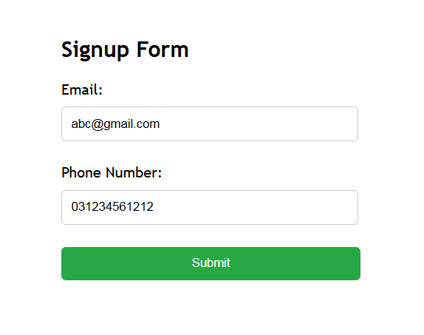

**1. NEGATIVE TESTING:**

Testing a self created signup form. This negative test case validates the form with incorrect input data to test whether it throws any errors or not.

